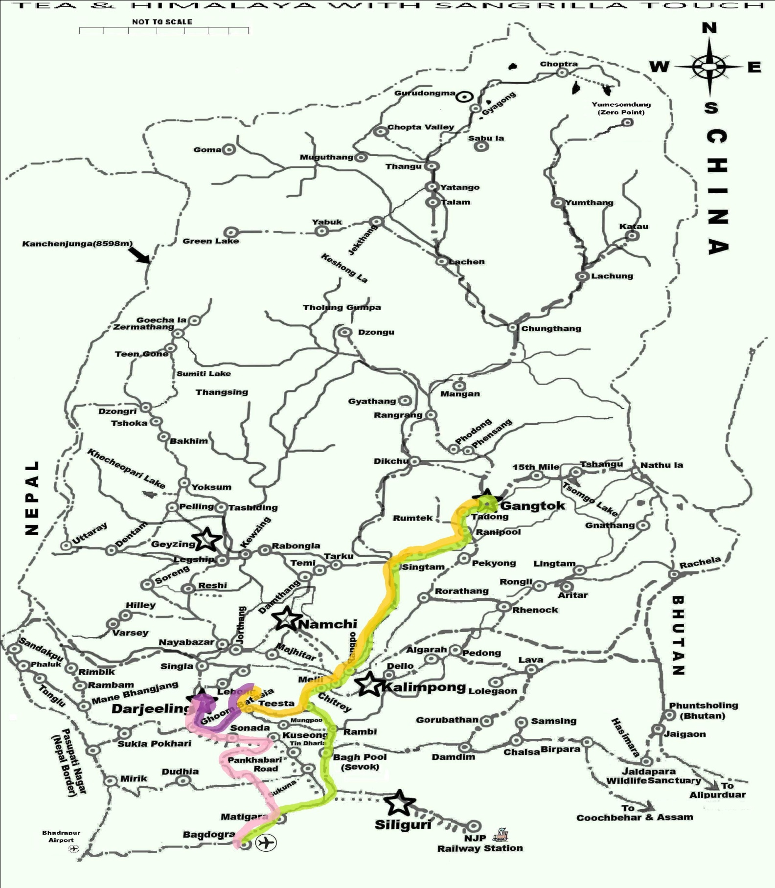

DAY 01 DAY 03 DAY 05 DAY 06

ITINERARY NO. HFH INB LAND -19

“TEA & HIMALAYA WITH SANGRILLA TOUCH”

ITINERARY 05 NIGHTS / 06 DAYS
BAGDOGRA AIRPORT / NJP RAILWAY STATION – GANGTOK (02 NIGHT) - GLENBURN (02 NIGHT) -DARJEELING (01 NIGHT) – BAGDOGRA AIRPORT / NJP RAILWAY STATION

DAY 01 ARRIVAL BAGDOGRA AIRPORT / NJP RAILWAY STATION - GANGTOK
On arrival at Bagdogra Airport / NJP Railway Station (400Ft / 122Mts), you will be met by our local representative who will assist you to board your vehicle to Gangtok (5500 Ft / 1677 Mts, 135 Kms / 4-5 Hrs). Overnight at Hotel.
DAY 02 GANGTOK
After breakfast go out for sightseeing covering Rumtek Monastery, Droul Chorthen, Research Institute of Tibetology, Directorate of Handicraft & Handloom (Closed on Sunday), Flower Show & Enchey Monastery. Evening free to explore Gangtok. Overnight at Hotel.
DAY 03 GANGTOK – GLENBURN
Today transfer to Glenburn (3200 Ft /976 Mts, 90 Kms / 4 Hrs). Over night at Glenburn.
DAY 04 GLENBURN
Today walk or drive through the tea garden with one of our guides, who will give you an insight into how the tea bush is grown and looked after. Learn how to pluck the "two leaves and a bud" - that is later manufactured into the tealeaf that ends up in your teacup! During the winter season, learn about the different types of pruning that is undertaken to increase the yield of the coming season. Interact with the Estate people. Later visit the Tea Factory where you will be taken for a guided tour on how the leaf is brought in from the garden, weighed, and then taken through the processes of Withering, Rolling, Fermenting, Drying and finally Sorting. The day ends with a Tea Tasting Session, where one can discover the differences in aroma, flavour. Overnight at Glenburn.
DAY 05 GLENBURN - DARJEELING

Today drive to Darjeeling (7380 Ft / 2250 Mts, 35 kms / 1.5 hrs). Check in at Hotel. Afternoon visit Padmaja Naidu Himalayan Zoological Park (Closed on Thursday), Himalayan Mountaineering Institute, Tibetan Refugee self-help (Closed on Sunday) Center & Tea Estate. Overnight at Hotel
DAY 06 DARJEELING – BAGDOGRA AIRPORT / NJP RAILWAY STATION
Transfer Bagdogra Airport / NJP Railway Station (100 Kms/ 3-4Hrs) for your onward connection.

COMMISSIONABLE RATE VALID FROM 01st APRIL 2016 TO 31st MARCH 2017
PARTICULAR | GRADE A2+ (MAPAI) | GRADE A1+ (MAPAI) | GRADE A (MAPAI) | GRADE B1+ (MAPAI) | GRADE B (CPAI)
FOR 02 PAX GROUP SIZE (PER PAX RATE ON 1 Xylo /Scorpio / Innova) | 82600 | 75700 | 71200 | 70500 | 66400
* FOR 3 PAX GROUP SIZE (PER PAX RATE ON 1 Xylo /Scorpio / Innova) | 75600 | 68700 | 64300 | 63500 | 59500
FOR 04 PAX GROUP SIZE (PER PAX RATE ON 1 Xylo /Scorpio / Innova) | 72200 | 65300 | 60800 | 60100 | 56000
* FOR 05 PAX GROUP SIZE (PER PAX RATE ON 1 Xylo /Scorpio / Innova) | 70100 | 63200 | 58700 | 58000 | 53900
* FOR 05 PAX GROUP SIZE (PER PAX RATE ON 2 Xylo /Scorpio / Innova) | 76100 | 69200 | 64800 | 64000 | 59900
SINGLE SUPPLEMENT (PER PAX) | 22000 | 18600 | 15100 | 12800 | 10600
MAP SUPPLEMENTRY (PER PAX) | INCLUDED | INCLUDED | INCLUDED | INCLUDED | 1200
AP SUPPLEMENTRY (PER PAX) | 700 | 1000 | 1300 | 1600 | 2200

- The above rates are on per person basis, in Indian Rupees (INR).
- * Incase of odd numbers travelling it is mandatory to add Single Supplement amount on the mentioned rate.
- The tour starts and ends from Bagdogra Airport. For all bookings on MAP, the Day 01 tour Meal starts with Dinner & ends with Breakfast on the last day of the tour at the booked hotels. For APAI, from Day 01, the Meal starts with Dinner at the booked hotel & ends with Packet lunch from the booked hotel on the last day.

Supplement for ONESIDE Pickup OR Drop to/from Darjeeling/Kalimpong/Gangtok will be as follows-
PICK UP OR DROP From DRJ / GTK / KPG to the below | Xylo /Scorpio / Innova
To Phuntsholing (Bhutan Border) | INR 3500.00 per vehicle
To Bhadrapur (Nepali Airport) | INR 3500.00 per vehicle
To Birathnagar (Nepali Airport) | INR 7000.00 per vehicle
TERMS & CONDITIONS COMMON TO PACKACES

HOTELS USED IN THE PACKAGES

PLACES | GRADE A2+ (MAPAI) | GRADE A1+ (MAPAI) | GRADE A (MAPAI)
DARJEELING | HOTEL WINDERMERE (APAI) | HOTEL NEW ELGIN | HOTEL VICEROY / CEDAR INN
GANGTOK | DENZONG REGENCY (SUITE ROOM) | ROYAL PLAZA  (CLUB ROOM) | ORANGE VILLAGE RESORT / SARAMSA RESORT
GLENBURN | GLENBURN TEA ESTATE (APAI) | GLENBURN TEA ESTATE (APAI) | GLENBURN TEA ESTATE (APAI)

PLACES | GRADE B1+ (MAPAI) | GRADE B (CPAI)
DARJEELING | LITTLE TIBET / RJ RESORT | VILLA EVEREST
GANGTOK | CHUMBI RESIDENCY / GOLDEN CRESENT | NEW CASTLE / HIMALAYAN HEIGHTS
GLENBURN | GLENBURN TEA ESTATE (APAI) | GLENBURN TEA ESTATE (APAI)

The Cost Includes (valid from 01st April 2016 to 31st March 2017 for Foreign National only)
- Agent Commission
- Government Service Tax as applicable (as on date 01/06/2015 it is 3.50%)
- Company Employed English Speaking Escort Assistance thought.
- Hotel Accommodation as per the name mentioned in the Category for duration as mentioned in the itinerary
- Meal Plan as per the details mentioned in the Hotel Bracket in BLUE.
- All applicable Transfers & Sightseeing as mentioned in the itinerary by XYLO / INNOVA / SIMILAR.
- Sightseeing Entry Fee as per the itinerary.

The Cost Does Not Include
- Change in Taxes by the government which will be collected directly upon arrival.
- Services mentioned separately as supplement cost.
- Cost for extra usage of vehicle, other than scheduled & mentioned in the itinerary.
- Cost for any other service not mentioned under the “Cost Includes” Head
- Cost for Airfare, Train fare, Insurance.
- Additional cost arising due to mishaps, political unrest, natural calamities like - landslides, road blockage, etc. In such case extra will have to be paid on the spot by the guest directly.
- Payment for service provided on a personal request.
- Personal expenses such as laundry, bottled water, soft drinks, incidentals, porter charges, tips etc.
- Cost for any increase in taxes / fuel price, which may come into effect prior to starting and ending of tour.

For Further Information Please Click on the Below Link:
FOR IMPORTANT NOTES ON FOREIGN NATIONAL TRAVELLING TO SIKKIM & DARJEELING
BOOKING AND PAYMENT PROCEDURE

